**GROUP BY CLAUSE**

**DEFINITION:**

1. Group by clause is used in select statement **to collect data across multiple records and group the result by one or more column.**
2. Grouping is done by using **‘group by’** clause.

**Syntax:**

SELECT <COLUMN_LIST><AGGREGATE_FUNCTION>

FROM TABLE_NAME

WHERE <CONDITION/S>

GROUP BY <COLUMN_LIST>

HAVING <CONDITION_BASED_ON_GROUP BY>;

**RULES:**

1. Whatever the column present in the select statement that should be present in group by clause
2. Whatever the column present in the group by clause need not to be present in select statement
3. Where condition is used to check the condition before grouping the data.it is used to filter non group data
4. We cannot use aggregate function
5. Having clause is used to restrict group data and it should be used after group by clause.

**EX:**

**1) Display the maximum of each job**

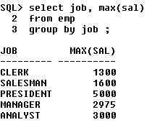

**HAVING**

1. **‘Having’** is used to filter the grouped data.
2. **‘Where’** is used to filter the non grouped data.
3. ‘**Having’** should be used after **group by** clause
4. **‘Where’** should be used before **group by** clause

**EX:**

**1) Display job-wise highest salary only if the highest salary is more than Rs1500**

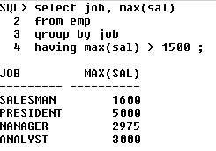

**RESTRICTIONS ON GROUPING**

1. We can select only the columns that are part of ‘**group by’** statement.
2. If we try selecting other columns, we will get an error as shown below,

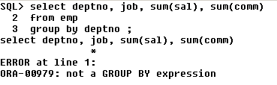

The above query is an error because ‘**job**’ is there in the **select** query but not in the **group by** query.

If it is enclosed in any of the **group functions like sum(sal)** etc – then it is not an error. But whatever table is included in the **select** query must also be included in the **group by** query.

The above problem can be overcome with the following query as shown below,

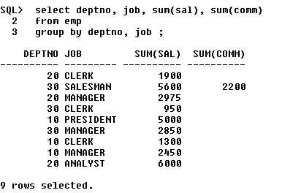

The below query is also correct to rectify the above error,

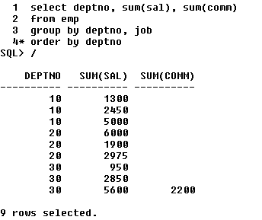

Whatever is there in the **select** statement must be there in the **group by** statement. But, whatever is there in the **group by** statement need not be present in the **select** statement. This is shown in the above two corrected queries.

**1).Display the maximum salary for each of the job excluding all the employees whose name ends with ‘S’**

